**Jan 2025 Information to all School teams for the**

**2025 Allsecure Selfstorage and Port Taranaki**

**Secondary School Teams Racing Nationals**

New Plymouth Yacht Club is looking forward to welcoming all the NZ teams at the upcoming Nationals.

Please take note of the following information.

**The dates of the regatta** are

Registration Easter Monday 21 April 1600 to 1730 hours

Welcome briefing Easter Monday 21 April 1800 hours.

All teams must be represented

Racing Tuesday 22 April to Saturday 26 April inclusive

Prizegiving Saturday 26 April 1900 to 2200 hours.

There will be a supper not a dinner at Prizegiving. Number 1’s required

See the NOR for more information

**Communications**: Our Club website regatta page will be posting all relevant information over the next 3 months. During the actual sailing week all information will be posted on our official physical club noticeboards. We will also upload information to the website [www.npyc.co.nz/events](http://www.npyc.co.nz/events) and the Stack TeamApp which is being setup.

If you need any other information about the regatta, please email [npyctreasurer@gmail.com](mailto:npyctreasurer@gmail.com). No question too big or too small.

**Email addresses**: Please share this information and links to all your team. If there is anyone you wish to be sent our emails directly then please let us know.

**Sailing Instructions:** These will be available once approved by YNZ

**Health and Safety procedures**: The NZTSA procedures are also on our webpage. Please ensure you have read them. In particular be aware of the implications of

NOR 1.4

**Entry forms:** Entry to the Nationals is via the link on the club website regatta page. There is a button for entries at the top of the regatta webpage. **Please ensure that your entry and full payment is made prior to 31 March.** Late entries or payments will not be accepted.

Once we have received your online entry, we will contact your Principal to confirm their approval. This is a School Sport NZ requirement.

You can request an invoice for the entry fee of $2,300 either by detailing on your entry or emailing us at [npyctreasurer@gmail.com](mailto:npyctreasurer@gmail.com). Please allow enough time for your school payments system to process the invoice and pay the fee before 31 March.

**Registration:** Please note that there is no team weigh-in at registration, but the coach or manager will be required to sign a declaration about any weights to be carried under NOR3.4. If you have sailors coming from the Howick Starling Nationals then they do not need to be at the Monday registration and briefing so long as some team members and the coach or manager are in attendance. Anyone who needs weighing can do so on the Tuesday morning if needed.

**Results**: All results will automatically be uploaded to the regatta page on the website and app from the results programme so please share the links so your family, friends and school mates can see your progress.

**Photos**: As per prior years there will be a photo of all competitors on Tuesday morning 22nd April in front of the Yacht Club. As required by School Sport NZ if you have any sailors that do not wish to have their photos taken, please advise us on your entry.

**Parking:** We have arranged for the grass area on the left of Ocean View Parade and across from the club carpark to be opened for team vehicles from Monday afternoon. This area will be locked each night by the security team. If you are bringing a Race Management rib, please park in the club carpark when you arrive, and we will instruct you about overnight storage. See the map at the end of this information for locations we will be using.

**Club facilities**: The club is a large building with a covered deck right on the sand of Ngamotu Beach. It will be used as the base for all regatta activities from registration to Prize Giving. Toilets, showers, and plenty of space for your gear is available.

We also have free Wifi available in the beach area curtesy of Primo. The link is “Free Primo Hotspot”.

Viewing of the racing is excellent from the club, along at the breakwater and the reclamation rocks area. We will have coverings over the deck and grass areas so there is no need for teams to bring gazebos.

Parents might also be interested to have a look at the 2 harbour cameras available to the public.

The Primo “Chimney North East” webcam on <https://primo.nz/info/primo-webcams>

And the NP Sportsfishing and Underwater club webcam <https://www.npsuc.co.nz/webcam>

During sailing days, we will have a barista working with coffees and hot chocolates available. We would appreciate it if you brought your keep cups to save on takeaway cup rubbish volumes. Our thanks to Carmen and Joop of InCafe Coffee for their generous support of the club and local teams.

We will also have some snack food available.

Please BYO water bottles.

The club takes cash, Eftpos, paywave and credit cards. Note there is a 2.5% surcharge for paywave and credit cards.

The Moturoa shops are just up the road from the club. There are lots of food options namely: good cafes, an excellent hot bread shop, a small 4 Square, Domino’s Pizza, a Kebab shop and a fish and chip shop.

There is also a pharmacy, a doctors and a BP service station amongst other shops.

The closest Supermarket to the club is Countdown Spotswood. The central one-way streets in New Plymouth also have Countdown, New World and PaknSave.

We will be happy to assist any camp mum/dad with food shopping locations.

**Changeover System:** It is our intention to sail the Nationals inside the Harbour confines. AS per last year we do not have a large team holding vessel so please be aware that our system is that all teams will be based in the club building during the regatta.

The 6 sailors that are due to sail next will be taken from in front of the club out on transfer ribs to changeover ribs. The team will stay on the changeover ribs until they swap onto their 3 yachts for racing. Once they have finished racing (usually 2 back-to-back races) they will go back onto the changeover ribs and then onto the transfer ribs for transport back to the beach.

Sailors must expect to get wet getting on and off the transfer ribs as these will come into the beach. Unfortunately, we do not have a jetty for transfers.

All reserves, coaches, and managers etc will always remain on the beach / at the club. All team gear, chilli bins etc can be kept at the club.

Our changeover Co-ordinator will be at the club with a PA system so all teams will know when they need to go out to the course.

Be aware that in April we can have cold days so we recommend all sailors bring beanies and warm gear. And if raincoats are handy then that might keep the rain away.

**Team Accommodation:** We hope you have all found and booked your accommodation. We understand that NP Boys High hostel still has spaces available.

Contact [jamie.stones@npbhs.school.nz](mailto:jamie.stones@npbhs.school.nz) for more information and booking at the hostel.

Also there are 2 camping grounds in New Plymouth with cabins and units.

Belt Road Seaside Holiday Park, [info@beltroad.co.nz](mailto:info@beltroad.co.nz) which is a 1km walk along the beach from the club, and Fitzroy Beach Holiday Park [bookings@fitzroybeach.co.nz](mailto:bookings@fitzroybeach.co.nz)

which is about a 7km drive from the club.

**Travelling to the regatta by Northern teams:**

When travelling down via Hamilton on the expressway if you need to stop at the takeaways then follow the Hamilton City and New Plymouth sign which will exit to the left just north of Hamilton.

If you do not need to stop then **do not** take the New Plymouth turnoff but continue on the expressway and follow the signs for Hamilton exits, Taupo and the Airport. You can then drive either to the Tamahere turnoff and go past the airport and Mystery Creek to rejoin State Highway 3 just north of Te Awamutu, or drive to the main Cambridge turnoff which has great cafes and toilets and that road rejoins SH3 at Kihikihi.

We can recommend a stop for all at Piopio Berry Orchard. This is located just north of Piopio which is south of Te Kuiti. It is open 9am to 6pm and has great coffee, berry ice-cream’s, fresh berries in season and good toilets. It is on the right-hand side of the road so take care when pulling into their carpark/drive.

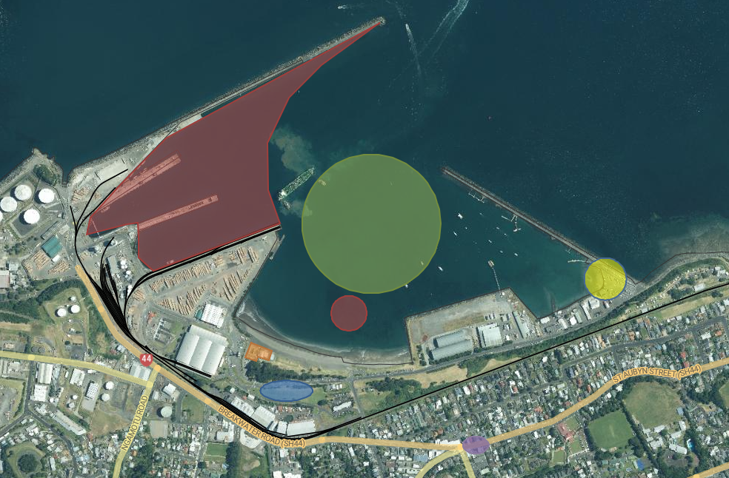**Map of the local area and harbour.**

**Red Zone -Out of Bounds (Port and reef)**

**Blue – Team Vehicle Parking**

**Green Zone - Indicative Racing area**

**Yellow – Public Launching Ramp for RIBs**

**Orange – New Plymouth Yacht Club**

**Purple – Moturoa Shops (BP, Hot Bread Shop, Pizza, Four Square etc)**

